Bug – customer can but more units or energy than are available.

Navigate to <https://ensekautomationcandidatetest.azurewebsites.net/Energy/Buy> and against Gas in units required enter 10000.

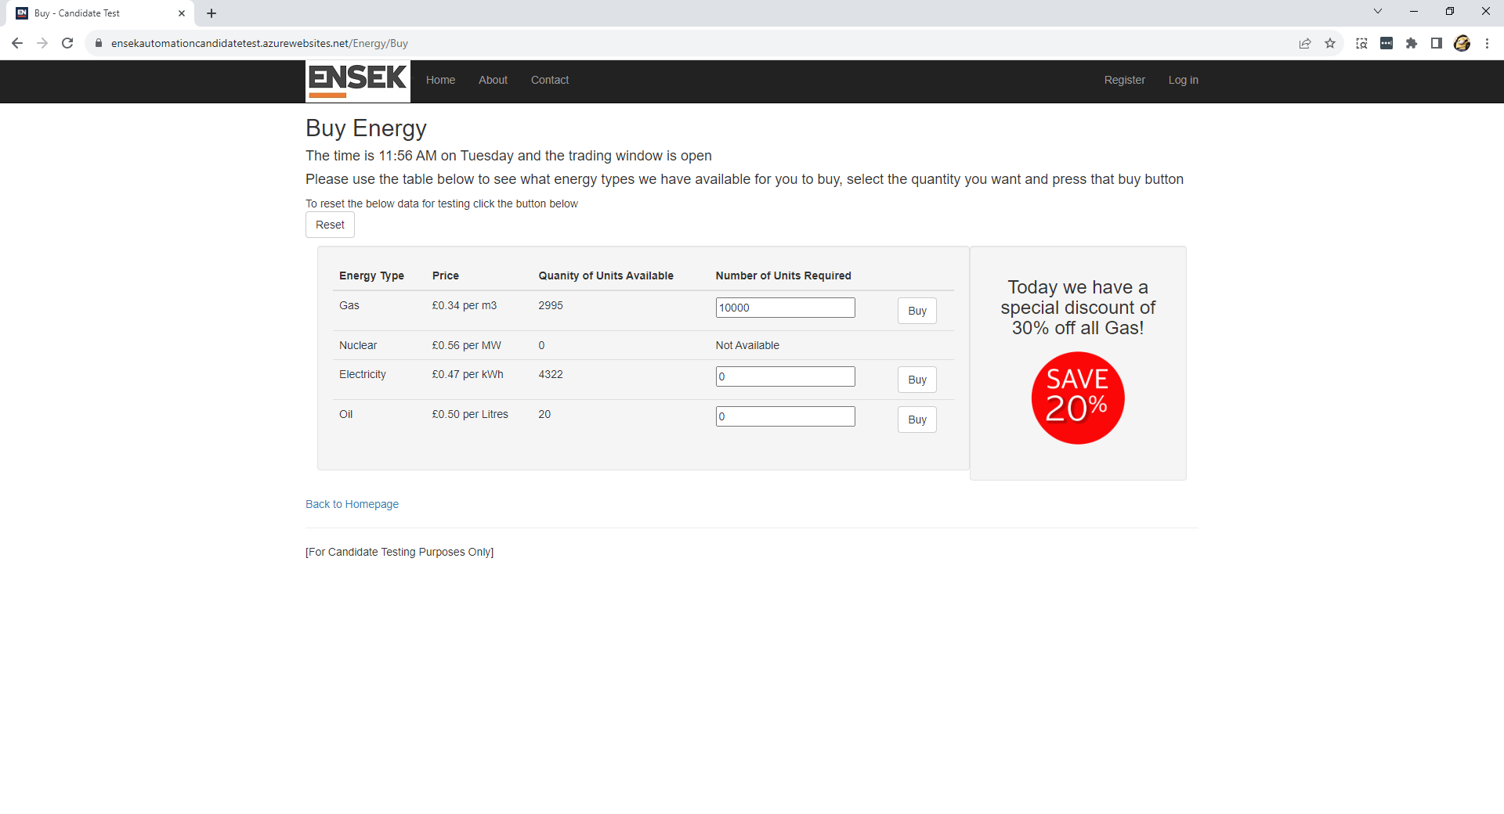

Select the buy button against the gas energy type. You will get the sale confirmed screen.

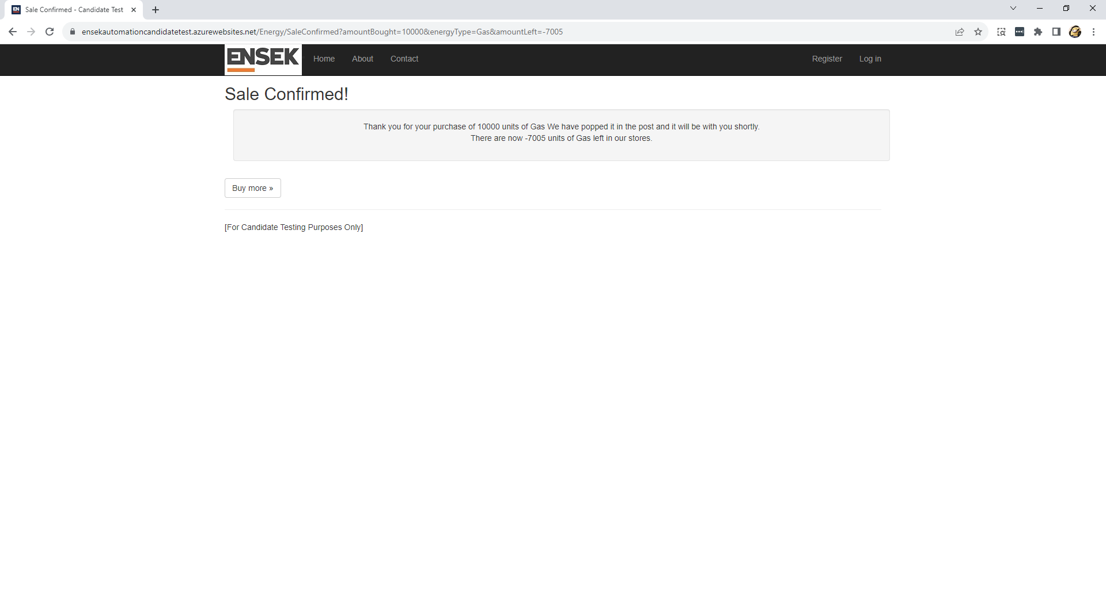

Select the buy more button to go back to the buy energy screen. Gass will no longer be available and have a negative number of units against it.

